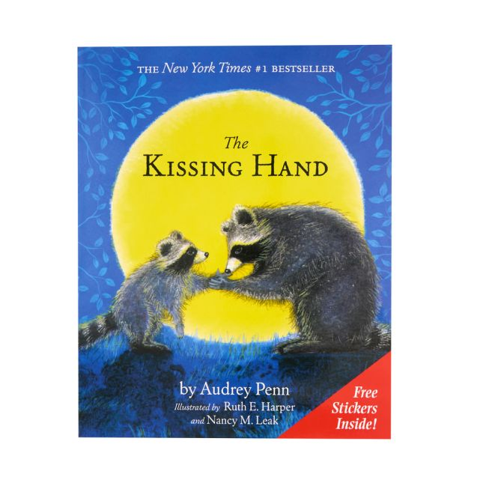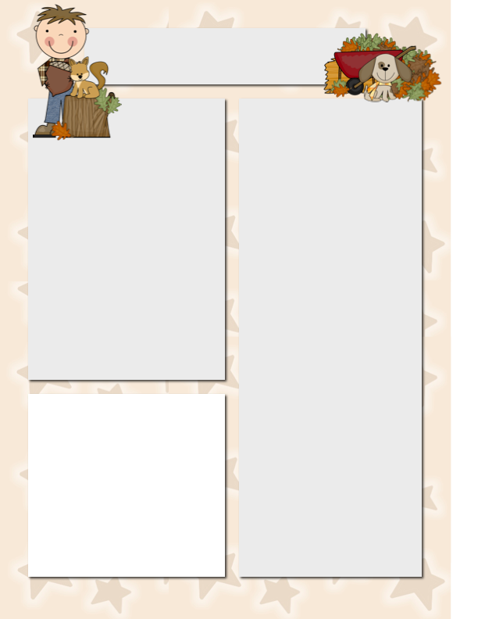

I know that many of you have read this book to your child, but I wanted to pass on as a great resource if your child has anxiety about school. We have read it as we talk about different feelings students may have in school.

**Announcements**

* **We have begun introducing letters of the alphabet. Each week I choose a letter or 2 associated with something we are learning about. We introduce the upper & lowercase letter, as well as the sound. This will allow us to get to most of the letters by Christmas & then review again the 2nd semester.**
* There will be NO school on Thurs. & Fri, October 2 & 3.

**Questions**

**Of the Day**

We will start the week by talking about what makes us happy & doing an activity where we need to try to “read” how a child is feeling. The rest of the week will be focused on our preschool routine.

**Monday:** What makes you happy?

**Tuesday:** What do you do when you get to school?

**Thursday:** What do you do after you wake up in the morning?

**Friday:** What do you do before/after? (focusing on our daily routine)

RV Christian Preschool News

***September 15-19***