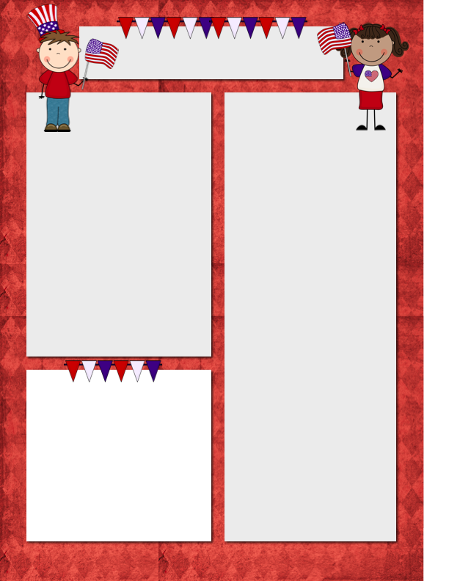
Announcements

- There will be NO PM preschool on Thursday, November 6 & NO school on Friday, November 7.
- Happy 5th Birthday to Case Leloux & Brielle Van Kley! They share a birthday on Nov. 2. Happy Birthday to Cole Van Dam! He will be 5 on the 4th.
- As you may have noticed, preschool conferences are only 10 minutes & there are many back-to-back on each of the conference nights. If you feel you need a longer time, please get in touch with me. I will be mindful of time, hoping to keep everyone on schedule.

Things to consider before conferences

- How is the year going?
- Does your child enjoy school?
- Are there any particular concerns I should be made aware of?
- What are some goals you have for your child as we go through the rest of the year & How can I help meet these goals?

Questions of the Day

I mentioned to the students that the tree study was just about over & I had someone say they would sure like to do a study on animals, so we will be investigating farm animals, zoo animals, & arctic animals over the next few weeks. I do not have plans written for the week of Nov. 10 yet, but I will include our questions for next week.
Monday – What animals live on a farm?
Tuesday – Do horses wear shoes?
Thursday – Do sheep need haircuts?

RV Christian Preschool News
November 3-14 (2 weeks)

