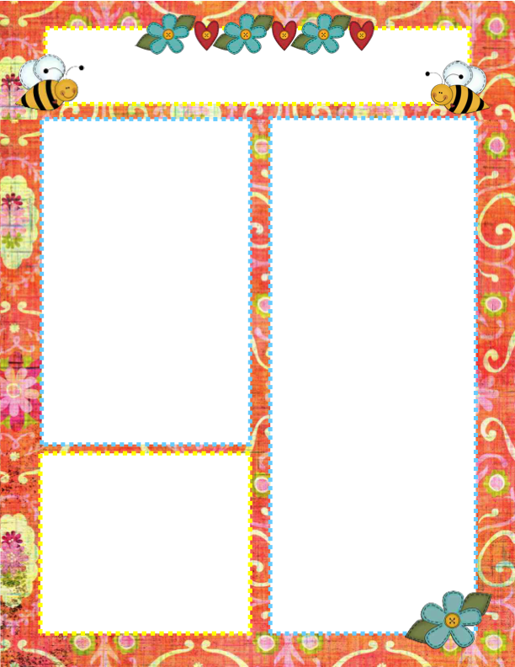

**Announcements**

* Please see the attached flyer about the “That’s my Brick” fundraiser. It is the goal for every class (not section) to have a brick added to the wall commemorating our school year. The cost of the brick is $100, & we would want just 1 brick for both sections of preschool. If you would like to contribute, please send donations by May 15.
* FYI – The last day of preschool for the ‘23/’24 school year will be Tuesday, May 21.
* Wanted: cool whip bowls with lids
* Thanks to those who helped with swimming! You could tell by the energy level in the classroom this week, that the students were very excited.

**Vocabulary**

list, circumference,

measure, rubber,

plastic, hallow,

solid

**Questions of the Day**

Our questions this week will help us investigate what different types of balls there are & how they are the same or different

**Monday** – What is your favorite ball in the collection?

**Tuesday** – Which ball is bigger?

**Thursday** – What is this ball made of?

**Friday** – What do you think is inside this ball?

RV Christian Preschool News

May 6 - 10