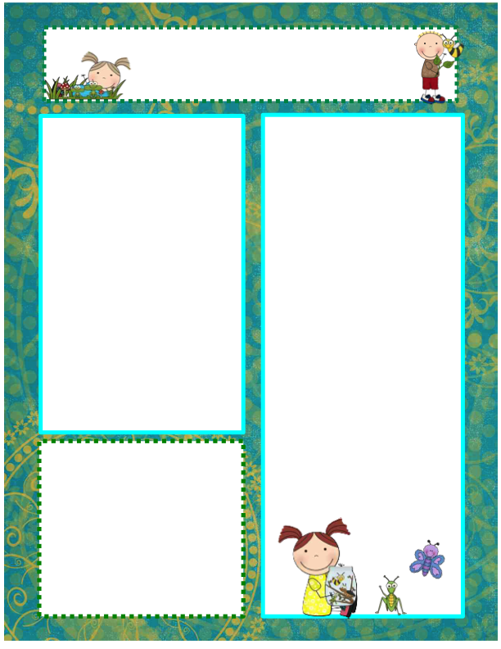

**Thank You!!**

* It is hard to believe the school year is almost over. It seems like just a short time ago that we began the year with a room full of quiet, timid, new students. It has been a wonderful year & I am so thankful for the awesome kids that were a part of each class. Mrs. Z & I have been truly blessed by your children! Thank you for sharing them with us & allowing us to be a part of their first school experience. Have a great & safe summer!
* To celebrate the end of the school year, we will be going to the park in Sioux Center on Tuesday May 20. Please have your child wear appropriate shoes for playing & walking.
* The last day of preschool for the school year will be

Tuesday, May 20!

* Happy 5th Birthday to Emmett Jacobsma on May 10! Happy 6th Birthday to Brooks De Jager on May 13!

**Questions of the Day**

We will finish the school year by investigating what it means to recycle.

**Monday** – Can you draw on both side of a sheet of paper?

**Tuesday** – Can you find the symbol on these items? (the recycle symbol)

**Thursday** – What do we put inside of this bin?

**Friday** – What do you think happened to the banana peel & the plastic bottle we buried outside?

**Vocabulary**

recycling, symbol, recycling bin,

biodegradable

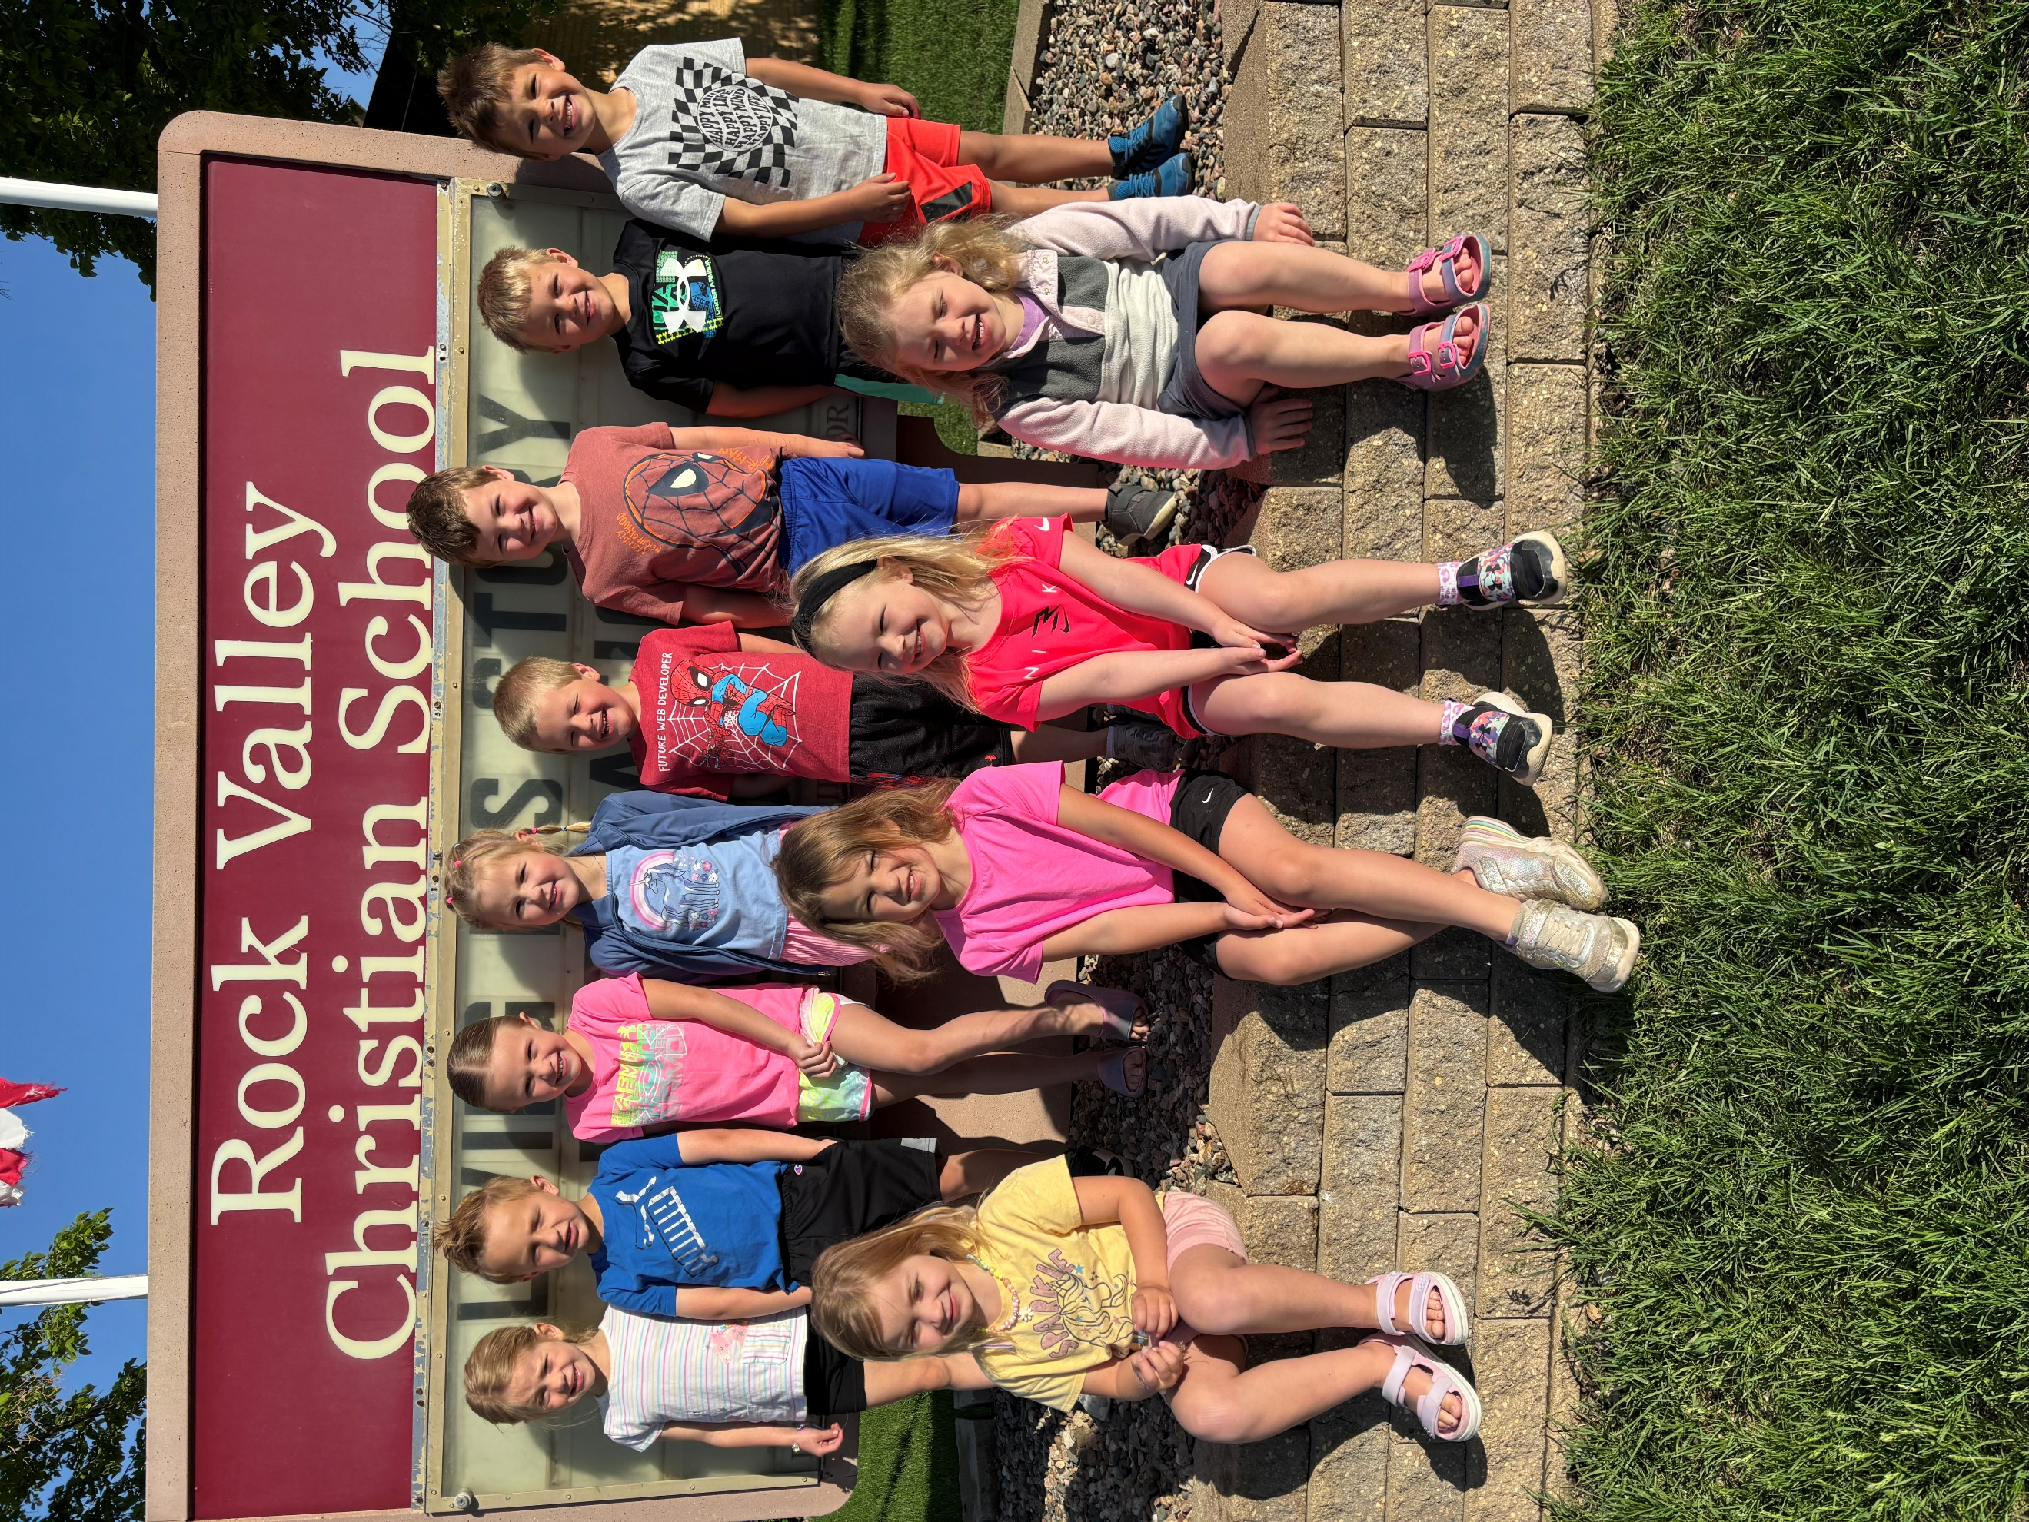

RV Christian Preschool News

May 12 – 20 Last Newsletter!!