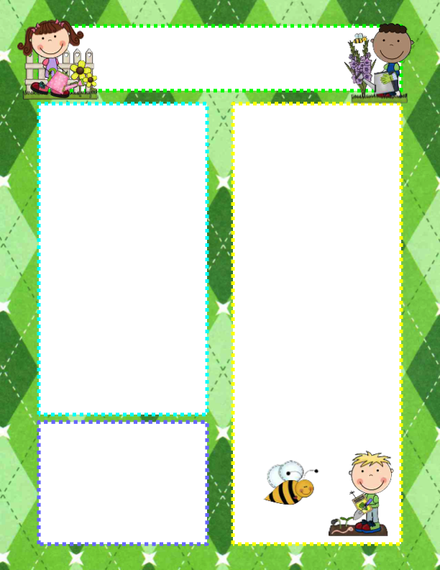

Announcements

- There is no PM preschool on Friday, March 13.
- There will be NO preschool March 16 – 20 for Spring Break!

Open house Information

PM Class – Thursday, March 12 – Parents & grandparents of PM students are welcome to visit preschool anytime from 12:20-2:30. We will have our regular 3:30 dismissal.

AM Class – Friday, March 13 – Visitors are welcome to visit the classroom anytime from 10:00-11:20. At 11:20 we will go as a class to “Jam the Gym”. We will dismiss to our classroom when that is finished at 12:00 & you can pick up your child from the room.

Thank You
As many of you know, my mom passed away last week. It has been a hard week, but teaching your children has brought joy & much needed routine. Thank you for your expressions of sympathy. For those who had conferences cancelled, please reach out (or I will be in touch) so we can reschedule.
Questions of the Day

Our investigations will continue to focus on different ways we use water & then move on to how water changes.

Monday: What type of cup is this? (measuring cup)
Tuesday: How do you like to play with water?
Thursday: Do you like to paint?
Friday: AM open house

Vocabulary

measuring cup, dilute, evaporate,
gas, experiment,
hypothesis

RV Christian Preschool News
March 9 - 13

