
Announcements
- Please send a $5-$7 gift to school for our gift exchange by Thursday, December 18. Along with indicating if it’s for a boy or girl, please include your child’s name on the tag.
- Friday, December 19 will be our final class before Christmas. Classes will resume on Monday, January 5.
- Happy ½ Birthday to Beau Faber! He will be 5 on June 20. Happy ½ Birthday to Weslynn Koedam & Oliver Nestegaard! They share a birthday & will each be 5 on June 28.
- The PM class will be joining the AM class at 8:20 on Friday, December 19. Although there may be a little bit of chaos, we look forward to the 2 classes meeting & connecting with each other. We are also looking forward to the 2 classes joining together their voices for our program. There will be NO PM preschool on that day.
- We will be having a small Christmas program on Friday, December 19 in the cafeteria at 11:00. Parents and grandparents are welcome to attend. We will dismiss for our Christmas break following the program.
- Advanced Notice: There will be NO PM preschool on Friday, Jan. 9 due to the end of the 1st semester.

Merry Christmas!
Merry Christmas everyone! May you all have a blessed and wonderful holiday season. We pray the peace and joy our Savior’s birth brought so many years ago, fills your home this Christmas & throughout the new year. See you in 2026!

RVC Preschool News
(last newsletter before Christmas)
December
15 - 19
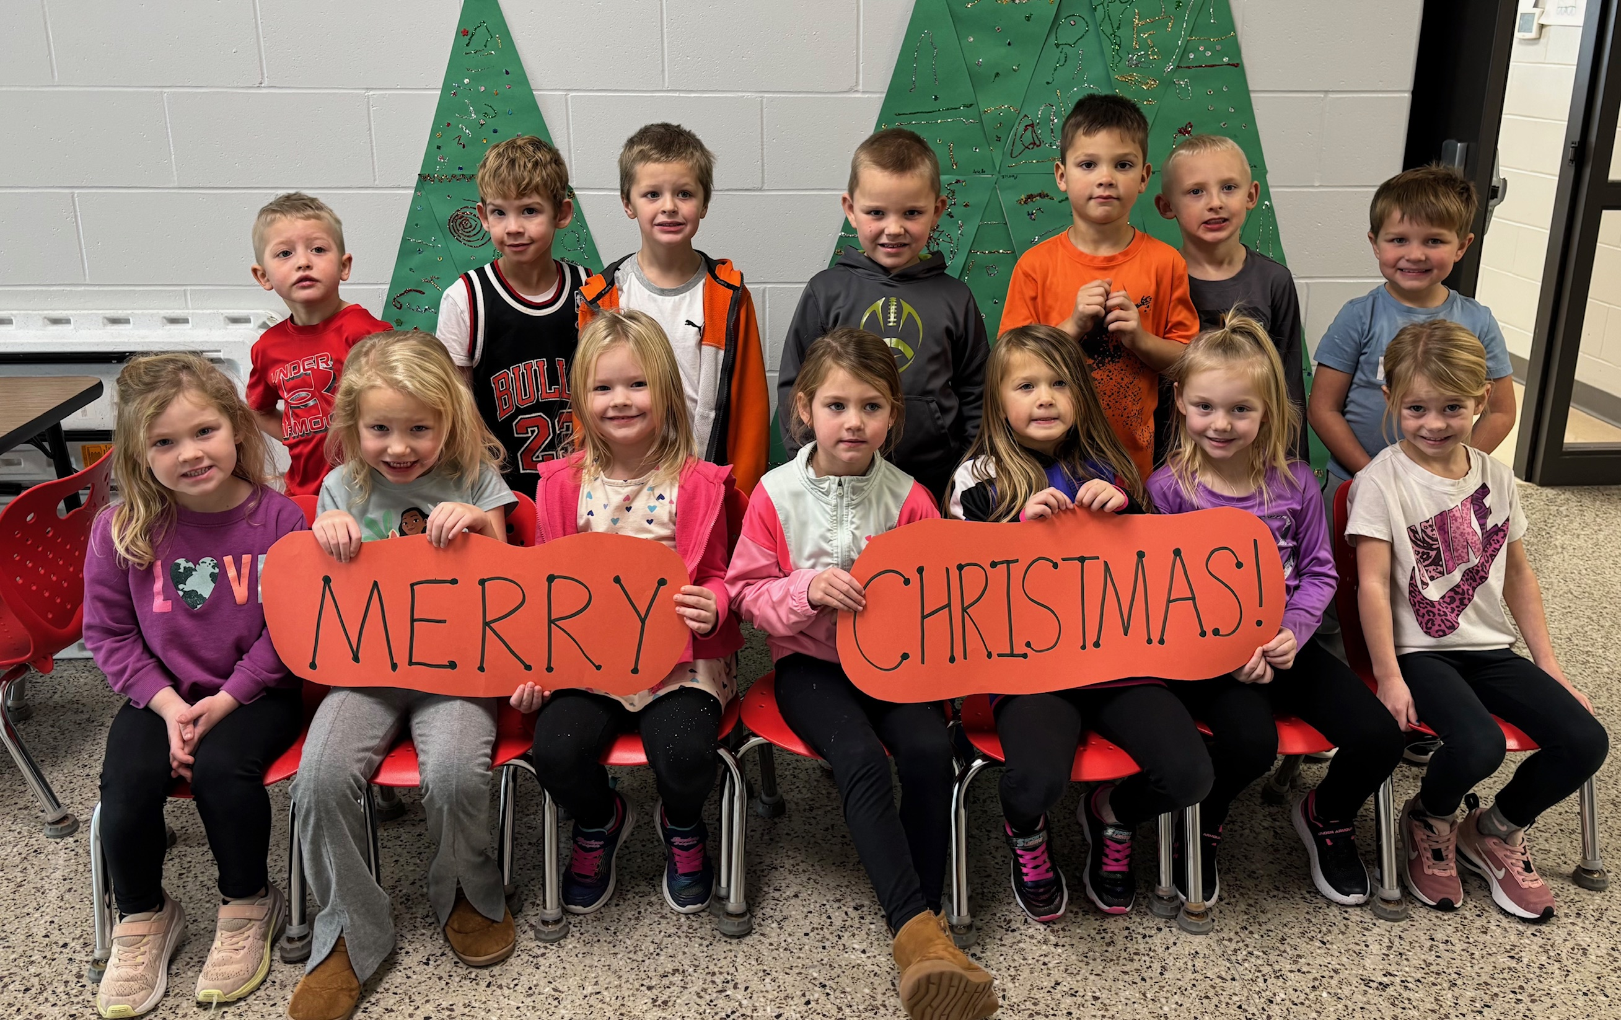

Coming Up

- In reading, blah, blah, blah, blah, blah, blah, blah, blah, blah.
- In writing, blah, blah, blah, blah, blah, blah.
- In math, blah, blah, blah, blah, blah, blah, blah, blah, blah, blah.
- In science, blah, blah, blah, blah, blah, blah, blah, blah.
- In social studies, blah, blah, blah, blah, blah, blah.
Dates to Remember

Month X Event goes here
Month X Event goes here
Month X Event goes here
Month X Event goes here
Month X Event goes here

Please remember…

It’s getting chilly! Please send a hat with your child.

