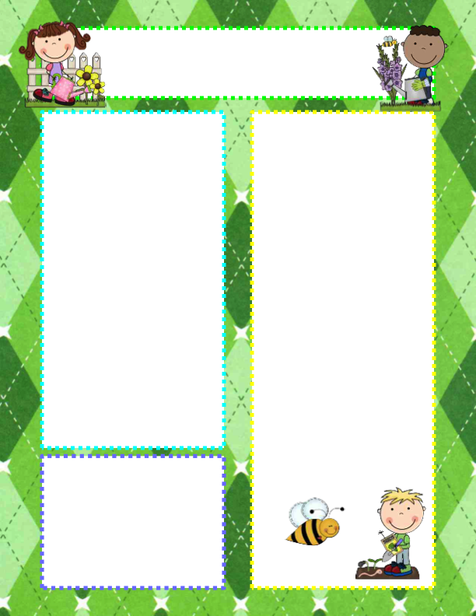

**Questions of the Day**

We are going to begin a new study titled “Reduce, Reuse, Recycle”. This is our last study of the school year. We may not be able to finish the study, but hopefully we will learn some skills that will help us take care of God’s beautiful world.

**Monday:** What do you put inside this container? (a trash can)

**Tuesday:** What have you thrown away today?

**Thursday:** Do you throw these items away?

**Friday:** Is there any trash inside this can?

**Vocabulary**

recycle, reduce, reuse, trash,

recycling bin, shredder,

custodian, paper, plastic,

dumpster, landfill

**Announcements**

* **Happy Birthday to Dolly Koedam! She will be 5 on April 29.**
* If you are missing anything from the balls study, please let me know.
* **Wanted: cool whip bowls with lids.**
* FYI – The last day of preschool for the ‘24/’25 school year will be Tuesday, May 20
* **For those students who will be repeating preschool, we will not be requiring students to bring their own school supplies. They will be provided in the classroom.**

**RV Christian Preschool News**

**April 28 – May 2**