INSECT COLLECTION ASSIGNMENT
The insect collection will consist of 15 properly pinned insects from a variety of insect Orders. All insects must be collected locally – no exotic specimens! Due Date: September 23 or 24

Materials needed
Euthanizing - The best way to kill the insects is to put them in a sealed bag or container in the freezer for at least a day. Pin within a couple of days before they start drying out. Another option is to make a small glass jar "loaded" with ethyl acetate (often an ingredient in fingernail polish remover) absorbed on a cotton ball.
Pins - Insect pins (long black pins made especially for insect pinning) or regular straight pins are required (no push pins).
Net and Book - A net will be very helpful in catching many insects. They can be purchased … or make your own. See Figure 4 for plans for making your own net. Even simple, hobbled-together nets can be very effective. ID Books may be checked out of the library either in town or at school. We have some that we will use in class. The internet is also very helpful and 5VH webpage has links to a few sites.
Box - A sturdy, covered box is necessary with a piece of Styrofoam to in the insects on. We have some Styrofoam for you if needed.
Field Guide or Identification Websites (only) – To help with identification, look at some of the many useful insect identification websites or complete insect Field Guide books. There are field guides available at the library or in 5th grade science classroom for use. (The students will also be learning about some helpful resources in class or check Ms. Van’t Hul’s science webpage!)

Pinning and Labeling:
Do not take insects out of the freezer until you are prepared to pin them. (They will dry out in the freezer so don't leave them in there more than a week or two.) Most insects are pinned through the thorax a little to the right of center, but beetles should be pinned through the right wing. Generally, insert the pin through the insect until the insect is approximately 1.0cm (3/8") from the head of the pin. Pin the insect onto a piece of thick Styrofoam until the insect rests near the Styrofoam. With the aid of pins or tweezers move the legs and antennae to a natural position. The insect will dry just the way you arrange it, so do this quickly and carefully. Leave the insect in this position for a week (or more for larger insects) to allow for adequate drying. Large winged insects (moths, butterflies) should be pinned on a piece of foam with a groove cut into it to accommodate its body; fix the insect in place with enough pins and paper strips to keep them flat (see Fig 3). Once dry you can lift them off the Styrofoam and move them to your box. These are suggestions for help on pinning, but you can do what works best for you!
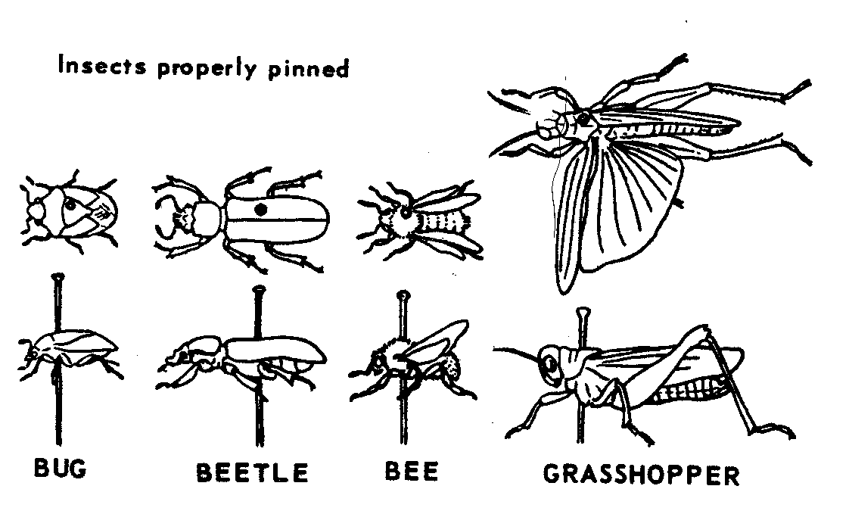
Fig. 1 Fig. 2 Fig. 3
Bug Beetle BeeGrasshopper

Insects properly pinned
*note location
1cm
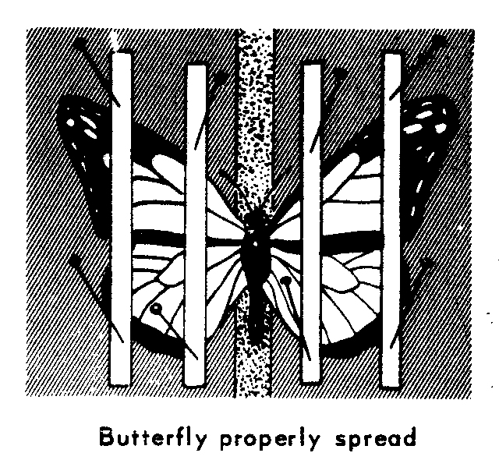
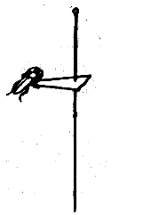
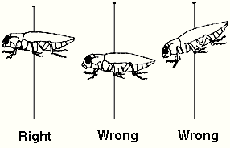

*Left wing extended only for grasshoppers and katydids
*Labels evenly and consistently spaced
Once they are dry, pinned specimens are to be labeled by a top and bottom tag which must include:
Tag 1 Tag 2
-location of capture -Order
-date of capture -Common name
-name of collector
example:
Hymenoptera
Yellow Jacket
Yolo Co., Davis, CA
Sept 8, 2002
John Doe

- Finally, display your collection in a box with Styrofoam on the bottom. A display box is not required, but helps to preserve the quality of the insects!
Metal coat hanger for example

Grading:
Fig. 4
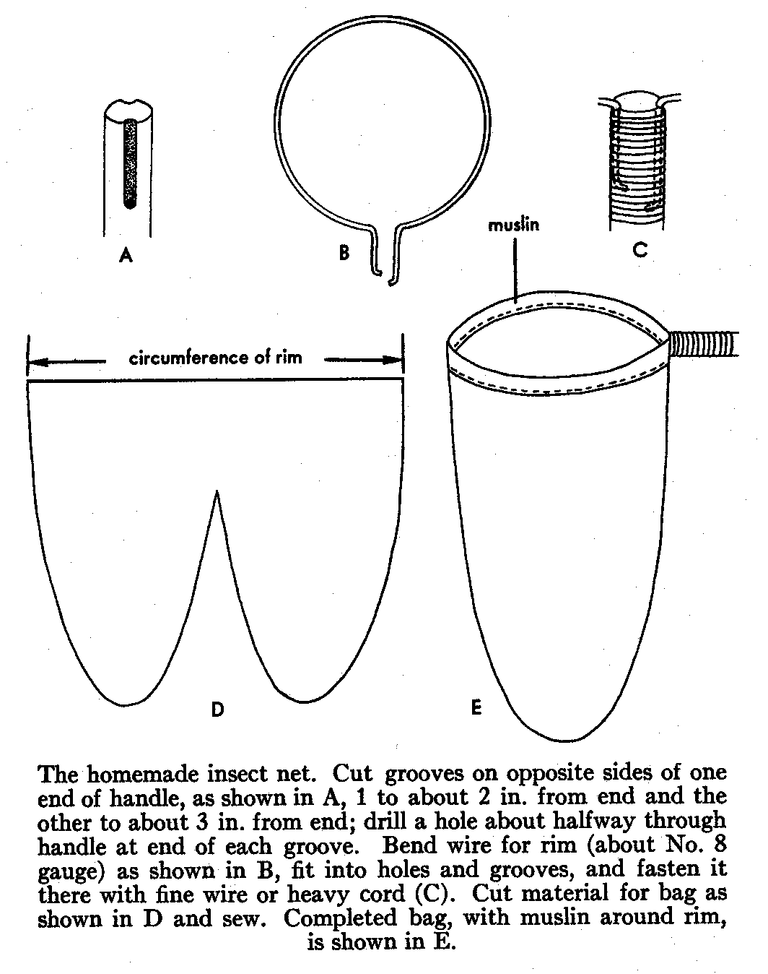
The goal is quality not just quantity. The criteria used for grading include: completeness, proper attempts at identification, pinning/labeling technique, effort, organization and overall neatness.
Please allow adequate time for the insects to dry before the due date. Be aware that it takes longer for some insects like mantids to dry.
A complete rubric has also been attached.
Checklist:

12-15 Insects :
Variety of Orders:
Quality:
Identification:
Display:
Neatness/Organization:
ID Tags

Insect Collection FAQ
Can I use an insect that my little brother caught for me?
Yes. Remember that you must put the collector’s name on the label after you pin it. It is just like citing a source on an English paper; failure to do so is equivalent to plagiarism. Also, if your collection has a significant percentage of insects that were not collected by you, then your grade will reflect that. (Just like an English paper that was entirely quotations without any of your own ideas.)
Can I use an insect that I bought or that was collected somewhere else?
No. All of the insects must be collected and pinned by you (or collected by your family/friends on your behalf). You may not purchase any insects or use those you collected from some far off land on last summer’s vacation to Peru. When in doubt, ask the teacher ahead of time!
Where is the best place to collect insects?
Anywhere outdoors! Enjoy creation and keep your eyes open!
Can I use insects from a previous year’s collection?
No. This is cheating. No insects may be used from previous students.
What do I do with an insect that is too small to pin?
Glue it onto the tip of a small paper triangle then pin the triangle.
What kind of glue do I use?
Any glue that dries clear; Elmer’s glue or clear nail polish work well.
Which way do the labels face?
They must be aligned with the body of the insect so that the words can be read on the left side of the insect’s body.
Do I have to spread the wings of small moths and butterflies?
Anything the size of a skipper or bigger (approx. the size of a dime) must have the wings spread properly (90-degree angle on the back edge of the front wings). You may keep the wings in a folded back position for smaller moths.
How do I pin a praying mantis?
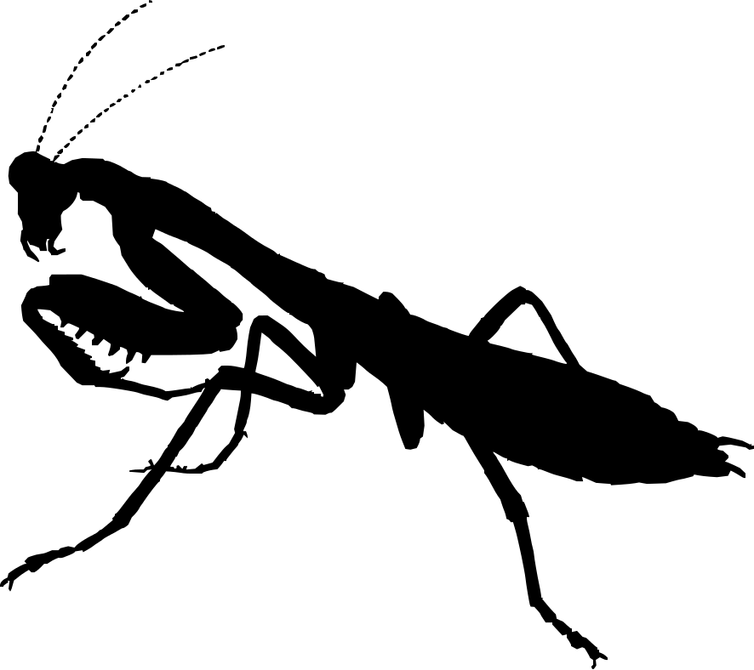
Put the pin through the thorax at an angle with the head higher and the abdomen resting on the styrofoam. The front legs should be in the “praying position” under its thorax. The back two pairs of legs are treated like the other insects. Don’t spread a wing. There will be little room under the mantis for labels, so they will be closer together than other insects.
Why do we KILL and collect insects?
Although it may seem best to preserve the insects, there are some valuable reasons for the assignment: 1. How fun to go outside and explore God’s creation--Sort of like a hunting trip! 2. We are able to look closely at the relationships in God’s web of life & how insects play an important role (even though they are small!) 3. Most species are common & abundant, so collecting is ok! 4. Close study allows us to look at life cycles, behavior, survival techniques, and God’s creativity & wonder. 5. Study brings knowledge and often knowledge helps us to appreciate more, instead of being scared of ‘bugs’!

Ten reasons for collecting and preserving insect specimens
There is an increasing trend to discourage collection and preservation of biological organisms including insects and their relatives. Although insects can be studied and enjoyed without killing them using observation and photographic methods, there are a number of reasons or benefits from procuring specimens:
1. Through collection and preservation efforts, new species are found and described. Many undescribed insects remain in the world, even in Iowa.
2. Properly preserved and stored insect specimens can be enjoyed and studied for hundreds of years while most insects live only for a period of days to months before they die and decompose.
3. Names and identities of insects (and other organisms) change over time when new studies reveal the need for a name change or can be compared to similar insects.
4. Insects are the most common form of wildlife encountered by people and are excellent models of living systems useful in learning about several fields of science. Most species are common and abundant and are not threatened by casual collection activities. Close observation of preserved specimens can result in an understanding of form and function of bodies or behavior, relationships between organisms or groups of organisms (, methods of identifying organisms, and life cycles .
5. During the exercise of collecting insects, collectors learn about relationships between insects and their environment, the importance of habitat, keys to species survival, and the relationships between species groups such as hosts, predators and parasites, i.e., trophic levels.
6. The study of insects in collections provides knowledge that can lead to a better understanding and higher tolerance of this group of animals in our environment. Ignorance about insects and their relatives can lead to an irrational fear of insects, called entomophobia (fear of spiders is arachnaphobia), or even psychological problems such as imagining that your body is infested with insects (delusionary parasitosis). Inability to determine beneficial insects (pollinators, predators, parasites) from pest insects can lead to unnecessary pesticide (insecticide) use.
7. Insects and their relatives are fascinating creatures so unlike ourselves. Yet they share many features with humans and other animals. People of all ages can participate in the study of insects and making an insect collection is an activity to be shared with others, providing enjoyment and exercise while being educational.
8. Many insect specimens are simply beautiful to the eye. Butterfly wings have been called “nature’s canvas.” Other insects are ugly and horrifying to look at. When mounted and displayed properly, insect specimens or insect parts can become an art form similar to taxidermists that display stuffed animals or artists using paint to make a picture.
9. Insect specimens make great souvenirs. Assuming laws and regulations pertaining to the collection and transport of biological specimens are honored, specimens collected on vacation trips can make useful reminders of these trips to far-away places. Properly maintained, the specimens can last more than a person’s lifetime.
10. Making insect collections, particularly bug hunting expeditions, are really fun! In a sense it’s like a real hunting trip, except you do not need guns or hunting licenses (with exceptions in some park lands). It’s generally a lot cheaper, too! Going bug hunting as an adult can even make you feel like a kid again.

Insect Collection Labels Use Order labels like the ones below to organize your collection. These should be placed on the foam in the bottom of the box, with the members of each order pinned in rows below the labels going from the back of the box to the front.
Protura
Dermaptera
Neuroptera

Thysanura
Ephemeroptera
Collembola
Odonata
Orthoptera
Isoptera
Plecotera
Embioptera
Psocoptera
Zoraptera
Mallophaga
Anaplura
Thysanoptera
Hemiptera
Coleoptera

Mecoptera

Strepsiptera

Trichoptera

Lepidoptera

Diptera

Siphonaptera

Mantodea

Hymenoptera

Location and Name Labels:
Blattodea

Phasmatodea

Prepared, pinned specimens are to be identified by a top and bottom tag which must include:
Top tag Bottom tag
-location of capture -Order
-date of capture -Common name
-name of collector
example:
Hymenoptera
Yellow Jacket
Yolo Co., Davis, CA
Sept 8, 2008
John Doe
As previously mentioned the labels below are available online as a Word document for you to fill in as you collect. Copy and paste to make additional tags.
(Top Tag)
(Bottom Tag)
(Top Tag)
(Bottom Tag)
(Top Tag)
(Bottom Tag)

Yolo Co., Davis, CA
Sept 8, 2008
John Doe
Hymenoptera
Yellow Jacket
Yolo Co., Davis, CA
Sept 8, 2008
John Doe
Hymenoptera
Yellow Jacket
Yolo Co., Davis, CA
Sept 8, 2008
John Doe
Hymenoptera
Yellow Jacket

